YDP (12-17) - Engagement Consent Form
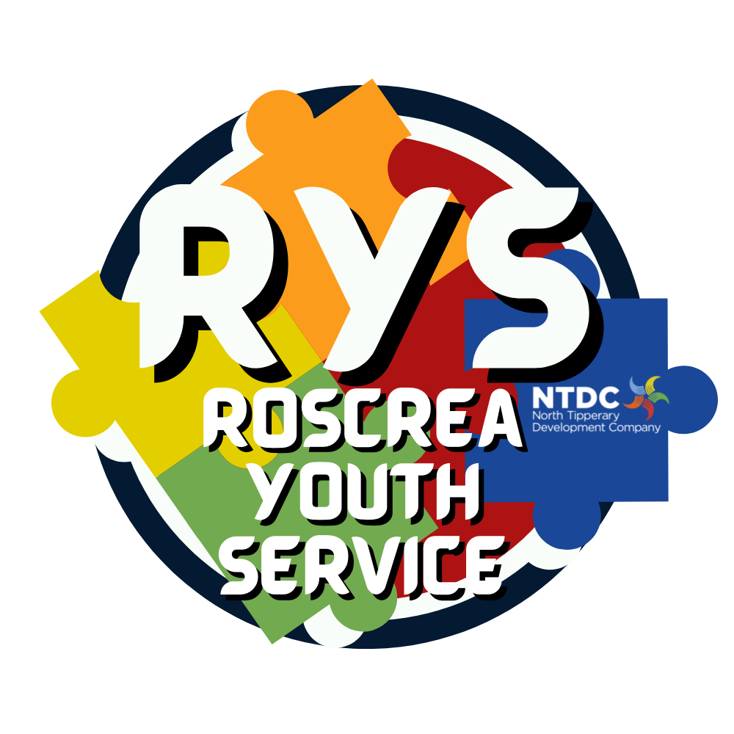
The RAY Project
For your young person to participate in the Youth Diversion Project this form must be fully
completed & returned to: The RAY Project, RYS, Rosemary St. Roscrea.

To be completed by Parent/Guardian
Family Contact Details

Young person’s name:
Address:

Name School/Training Centre (if applicable)

Mobile number: | Date of birth:

Parent / Guardian name: | Relationship to young person:
Address: (if different from young person)
Mobile number:

Medical Details; I undertake to inform the project should my young person’s medical condition change.

Does the young person have any medical conditions that may impact their involvement with the Youth Diversion Project: Yes □ No□
If yes, please provide details:

Does the young person have any other condition(s) that staff should be aware of, which may require individual planning and consideration, including conditions affecting learning or social interaction? Yes □ No□
If Yes, please provide details:

Please tick that you have received, read, and understood the Information Leaflet on Data collected by
Youth Diversion Projects □

YDP (12-17) - Engagement Consent Form

The RAY Project

Parent/Guardian Consent

I understand that the Project works with other agencies; An Garda Síochána, Tusla and schools/education centres, social workers and counsellors to ensure that the young person’s needs are met in the best way possible. This may involve sharing relevant information with them. I understand that the young person’s needs will be assessed to help create a plan for them. I also understand that this information may be used to compile statistical data to be transmitted to other relevant organisations; Department of Justice, Department of Further and Higher Education, Research, Innovation and Science, University of Limerick, MHS Assessments, European Union agencies and other relevant bodies which the Department of Justice may decide for the purpose of conducting evaluations and research. I understand that my young person’s pseudonymised data will be stored on behalf of the Department of Justice. I understand that this information will be kept in accordance with the Data Protection Act 1988, 2003 & 2018. I agree to this.
Please circle yes/no to the following statements
I grant permission for _________________________________________________ (name of young person) to:

- Engage in the Youth Diversion Project Yes No
- Be included in publicity material provided to European Social Fund Plus (ESF+) Yes No
- Take part in programmes/activities in the Project (incl 1:1’s, group sessions etc.) Yes No
- Be taken to A&E/a doctor in case of medical emergency Yes No
- Visit and leave the Project during drop-in times at their own discretion Yes No
- Participate/Attend Event nights, Overnights and/or Day trips with the Project Yes No
- Be included in any publicity photographs for the Project/CBO Yes No
- Be contacted directly by a Youth Justice Worker regarding project activities Yes No
Signature: __________________________________________ (Parent/Guardian) Date: ______________

Young Persons Agreement

This Youth Diversion Project is committed to providing a service to all suitable persons irrespective of their gender, ethnic background, culture, sexuality, ability, or religion. Our activities are based upon the principle of respect. Bullying in any form will not be tolerated. As a participant in the project, I agree to follow this equality statement. I also understand and agree to the project using what they know about me to plan activities and programmes to meet my needs in the best possible way.

Signature: ____________________________________________ (Young Person) Date: ____________

