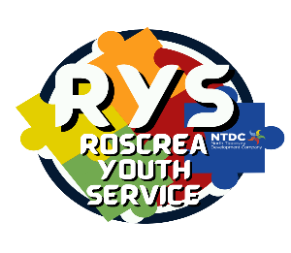
YDP (12-17) Screening Consent Form The RAY Project]

For your young person to be considered for inclusion in the YDP this form must be fully completed & returned to: The RAY Project, RYS, Rosemary St. Roscrea

To be completed by Parent/Guardian
Your young person has been referred to [name of YDP] by _____________________ (name of referrer). The Project will assess your young person’s needs to ensure the YDP is the most suitable service for them at this time. [YDP Name] works with other agencies such as the An Garda Síochána, schools, TUSLA etc. to provide the best possible service to young people and their families. This may involve sharing information with them. If [YDP name] is not in a position to meet your young person’s needs, we may recommend a more suitable support for them. If you would like your young person to be considered for involvement in [YDP name] please read and complete the following:

Young Person’s name:
Address:

Date of Birth:

Parent / Guardian’s name: | Relationship to Young Person:
Address: (If different to young person)

Mobile Number | Home Phone

Please tick that you have received, read, and understood the Information Leaflet on Data collected by Youth Diversion Projects □

Consent

I understand that my young person’s needs will be assessed to help decide if the YDP could be of benefit to them. I understand that the project works with other agencies to ensure that my young person’s needs are met in the best possible way. This may involve sharing relevant information. I agree to this.

I also understand that this information will be kept in accordance with the Data Protection Act 1988, 2003 & 2018

Signature: ____________________________________ (Parent/Guardian) Date: ______________

Signature: _____________________________________(Young person) Date: ______________

