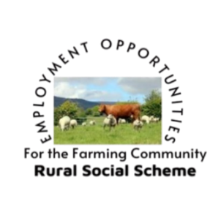
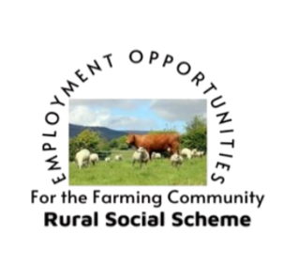
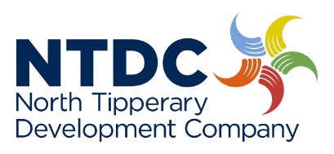

New Employment Opportunities on the
Rural Social Scheme in 2026
As a result of a review of the Rural Social Scheme, the final report included a number of recommendations to address the sustainability of the RSS, which include the following three recommendations which will be implemented from January 2026:

These recommendations will open eligibility to a whole new cohort of people in the community.
If you are on a qualifying Social Welfare Payment and satisfy any of the following 3 criteria, you may be eligible to apply for a position on the RSS.

1: Rural Dwellers:

A Rural Dweller is a person who is 50 years or over, in receipt of a qualifying social welfare payment and whose primary residence is in a rural area.
(As set out by the DRCDG Leader Programme, the rural area is defined as all parts of Ireland with the exception of the areas within the boundaries of the five main cities of Dublin, Cork, Limerick, Waterford, and Galway).

2: RSS ‘Defined Connection:
From January 2026, RSS “Defined Connection” is a person who is 25 years or older, in receipt of a qualifying social welfare payment and has a “defined” connection to the farming number or fishing licence owner. This person must be actively engaged in farming or fishing.
A “defined” connection is described as
a member of the farming number/fishing licence holder’s “family” (detailed below, or
a person engaged in farming or fishing who is not “family” but is actively engaged in the activity.

A “family member” is described (including in-laws) as follows:
• spouse/civil partner/co-habitant,
• father/mother,
• son/daughter,
• brother/sister,
• grandfather/grandmother/grandchild
• niece/nephew
• aunt/uncle

3: RSS Couple engaged in Farming/Fishing:
From January 2026, RSS is available to the spouse/civil partner/cohabitant of a Farmer/Fisherperson. The spouse/civil partner/cohabitant must be 25 years or older, actively engaged in farming/fishing and in receipt of a qualifying social welfare payment.
Eligibility is also extended to the spouse/civil partner/ cohabitant of a current RSS participant who is in receipt of a qualified adult allowance. This person must be 25 years or older and actively engaged in farming/fishing.
For further information, please contact:
Mary O’ Dwyer Rural Social Scheme Supervisor. 087:9109261 or email : modwyer@ntdc.ie

